
To what extent should we embrace globalization?
 | In this Unit we will be exploring the meaning of globalization and how it affects you. Understanding the role globalization plays in your life today, will help you to form opinions about the extent to which you feel we should embrace it.  Globalization is a key concept that permeates our lives. Look at your life and where the things you are wearing or using come from. You will notice that very few things around you were created in Canada. Most of the things you wear, eat, and use come from a variety of different places where other people live, work, love, and dream just as you do.  To better understand both your world and how it interconnects with the rest of the globe we are going to explore the concept of globalization, what it means, how it has evolved, and how it impacts our lives and world.

Global or Local? Where do some of the things you use and wear come from?
Are the following object Canadian or do they have their original source outside Canada?
In your notes, make a table with two columns, one column for Canada (Maple Leaf) and one for Outside Canada (Globe) and list the items in the category you think they belong:

Click here for the answers and compare to what you thought was the original source. Photo Credits

Vocabulary
Below are the key vocabulary terms you will want to understand in this unit.
accommodation  acculturation  assimilation  collective identity  cultural globalization  cultural revitalization  digital divide  economic globalization  environmental globalization  globalization  homogenization | hybridization  individual identity  marginalization  media convergence  multiculturalism  perspective  political globalization  social globalization  transnational corporation  worldview  universalization

©2020 CBE-learn - Calgary Board of Education


Aspects of Globalization
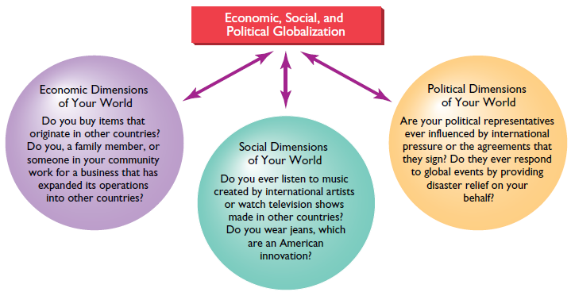
Watch:
Iframe preserved from Brightspace: Globalization I - The Upside: Crash Course World History #41
https://www.youtube.com/embed/5SnR-e0S6Ic?feature=oembed&rel=0

Reading
Please read Chapter 1 pages 6-19 in your Perspectives on Globalization textbook.

 Image source
How is economic globalization at work in your life?
Global economic connections play a big role in our daily lives. How many of the products you use are made or sold outside of Canada? Does your family income have any connection with the global economy? Goods and services created today are easily shipped from one country to another, and this gives many people and companies an opportunity to prosper.
Many of the items we buy every day are the products of transnational corporations. A transnational corporation is a corporation that operates in two or more countries. Most large transnationals operate in several countries and the largest of these have more money than many entire countries. For example, Wal-Mart is based in the United States, but it has stores all around the world. Many of the products sold in Wal-Mart are made in factories in China, where pay is much lower than in North America.
Watch:
Iframe preserved from Brightspace: YouTube video player
https://www.youtube.com/embed/onD5UOP5z_c?si=Ed4OK6Ssz_cyMSiQ&rel=0

McDonald's Franchises Around the World
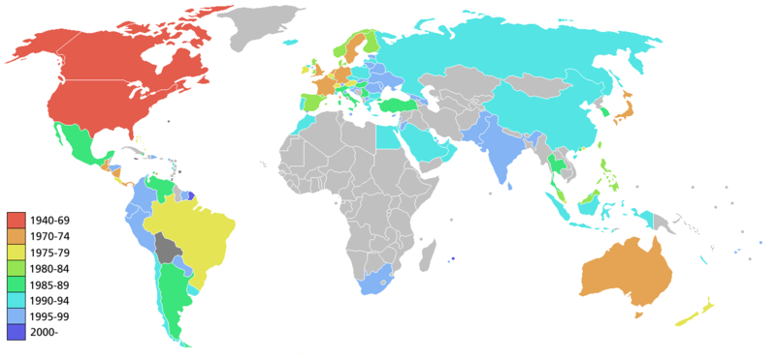 Image source
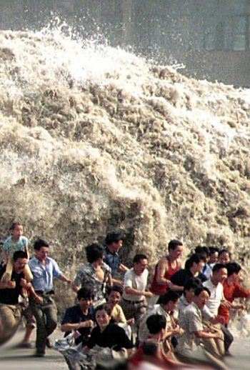 Image source
How does globalization affect political aspects of your life?
Globalization also has a big role to play in political aspects of your life. When events take place far away, they may have an impact on your life. For example, if Canada decides to go to war, this affects how Canadian soldiers and their families live. Their contributions may make Canada and the world a better, safer place. However, when tax dollars go to support that war, it means there is less money for other government programs. If the Canadian government chooses to take measures to protect the environment from climate change, there are costs associated with these actions. Of course, there are also costs associated with not acting to prevent climate change as well. The federal government may send aid to countries in need if there is a disaster. It may try to convince other countries to treat their citizens more equally. When global events occur, your local politicians may be forced to act. For example, your mayor and town or city council may have to make decisions about the environment. Your provincial government may find that it has to make deals with transnational oil companies to encourage economic growth and create jobs in Alberta. All of these decisions have an impact on you.
Tiananmen Square, G8protests in Quebec City,2004 tsunami (pictured), Afghanistan, Caledonia, Ontario and Hurricane Katrina are examples of issues that illustrate political globalization.
How does globalization affect social aspects of your life?
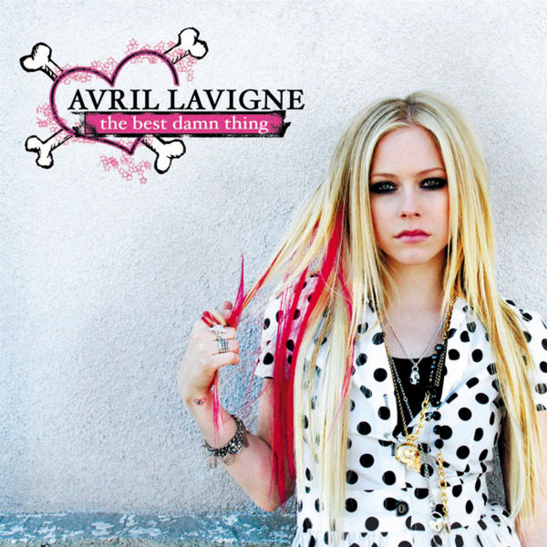 Image sourceSocial Globalization refers to global access of popular culture. Avril Lavigne recorded the song "Girlfriend", released in 2007 in French, Portuguese, German, Italian, Spanish, Japanese, and Mandarin.
Globalization has an impact on social aspects of your life. By looking at the historical background to globalization, you learned that your ancestors were connected with people from other parts of the world. Today you are even more connected. For instance, you can connect with people all around the world through the Internet, whether it’s through social software, gaming, or e-mail. You may have friends and family all over the world.
The nature of work also affects social aspects of your life. Many globalizing forces have an impact on who you are and how you interact with others. If people all over the world start wearing the same clothing, drinking the same kind of pop, and eating the same brand of food in the same style of restaurant, how would this affect how they live? How would their lifestyle affect who they are? You may not notice the impact of big companies such as Coke, Disney, and McDonald’s because they represent the mainstream culture of which you are a part. Think about their impact a little more. In your grandparents’ day, women usually worked in the home. Now most women work out of the home, partly due to global social changes. This affects how families live. In your parents’ day, chances are that families all ate together, cooking and eating food that grew nearby. Now that there are global shipping networks and cheap fast-food outlets, many families order takeout or go to fast-food restaurants, spending less time together. Globalization may be changing your lifestyle and the lifestyles of people all over the world in ways that you have not considered.
Environmental Globalization involves the ecological issues that concern the world. Individuals are responding to their immediate environment while keeping the consequences on a global scale in mind.
Perspectives on Globalization

An Interview with Thomas Friedman "Why the World is Flat"

©2020 CBE-learn - Calgary Board of Education


Technology and the Promotion of Culture
Access to new media and communication technologies is very evident in entertainment, quick global contact at your fingertips, and in the pop culture side of the everyday lives of many people. This aspect of globalization influences economic, social, and political dimensions of society. These technologies can unify a community across great distances and geographical obstacles. With these tools, people can instantly be informed by a click of a mouse or a tap of a finger. These tools also create opportunities and challenges to maintaining unique cultures and languages.
Some who view globalization as limiting predict that these technologies will develop a homogenized pop culture that will dominate diverse cultures. Some would argue that this may even lead to a complete erosion of those cultures in favor of a single one, especially as people use these technologies more and more often. Those who recognize the potentials of globalization use these technologies to establish a space for the maintenance of their culture, language, and identity in a globalizing world. They may make the case that changes in technology and media gives a new voice to marginalized and oppressed cultures, and a way to stand up for themselves.
[Unresolved image: ../smartphone-addiction-illustrations-cartoons-2__605.jpg][Unresolved image: ../iran%20twitter%20cartoon.jpg]
On the left; a cartoon pokes fun an the increasing use of cellphones, expressing a position that they are overused and hurt people's ability to connect with one another. On the right; a cartoon references the role played by smartphones and twitter in organizing protests and spreading information during Iran's violent suppression of protests after the election of 2009. What viewpoints on technology are expressed here?
Comics taken from bizzarocomics.com and toonpool.com
Reading
Please read Chapter 3 pages 46, 49-57 in your Perspectives on Globalization textbook.

Lesson Summary
Cultural diversity in the twenty-first century can be challenged by global forces such as media and communication technologies. These technologies, which allow people rapid communication and exchange, can make room for expressions of cultural diversity, or they can replace such diversity with a universalized pop culture and language. In the next lesson you will examine how collective identities attempt to promote their unique culture and language in response to the challenges and opportunities globalization may present.
Enrichment - Technology and Culture
To further explore the role of technology in identity and culture, watch the following TED Talks videos (about 20 minutes each):
How technology evolves:
Iframe preserved from Brightspace: Embedded media
https://embed.ted.com/talks/kevin_kelly_how_technology_evolves

How technology will transform us:
Iframe preserved from Brightspace: Embedded media
https://embed.ted.com/talks/ray_kurzweil_the_accelerating_power_of_technology

Birth of Wikipedia:
Iframe preserved from Brightspace: Embedded media
https://embed.ted.com/talks/jimmy_wales_the_birth_of_wikipedia

Globalization & Education: Open source learning:
Iframe preserved from Brightspace: Embedded media
https://embed.ted.com/talks/richard_baraniuk_the_birth_of_the_open_source_learning_revolution

©2020 CBE-learn - Calgary Board of Education


Media, Technology and Cultural Exchange
Your individual identity can be easy to describe or it may be very complex. Who you are can be connected to your community, your language, your values and beliefs—even to how you dress and the activities you prefer. Often people think of their individual identity as a matter of personal choice. When the influences of globalization in the twenty-first century are examined, you may find that global contact and connections can also influence your personal choices about who you are. Understanding the forces of globalization and how they shape who you are, both individually and collectively, is the focus of this lesson.
[Unresolved image: assets/soccer.png] | The Olympics, World Cup, and student exchanges are some examples of cultural exchanges. How do such exchanges affect the identities of participants? What cultural exchanges have you been a part of (example: linguistic, athletic, musical, educational)? What did you learn from those exchanges?

Universalization - A Canadian Example
[Unresolved image: assets/movie.png]The majority of the popular culture we watch, listen to, and read, comes from media transnationals who own many smaller media outlets which create and broadcast their own materials. For example, the transnational Comcast owns NBC, Bravo, SportsNet, History Channel, Style, and 24 other TV and Radio channels.
Transnational media and communications corporations enable a large population of people around the world to gain access to the latest movies, music and pop culture. This universalization of culture through media transnationals has both advantages and concerns.
Within Canada, we have the Canadian Radio and Television Commission (CRTC) whose purpose is to regulate and promote Canada culture, national identity and cultural sovereignty in the broadcasting media to “ensure that all Canadians have access to a wide variety of high quality Canadian programming” (Broadcasting Act of 1991). The CRTC regulations determine the minimum amount of Canadian Content (CanCon) that Canadian broadcasters must show.
[Unresolved image: ../Screen%20Shot%202017-01-05%20at%202.02.30%20PM.png]
Professor William Stanbury does not agree with the CRTC regulations regarding amount of Canadian Content: “The present Canadian content regulations have almost no redeeming social value. They are based on citizenship, not on the substantive content of TV programs or musical recordings. They alter the set of choices available to TV viewers and radio listeners by limiting the availability of foreign programs and musical recordings.” (as quoted in Atlantic Institute for Market Studies, 2008).
With the rise of Internet streaming to watch TV shows, movies, and videos, and to listen to music and news, there is discussion regarding whether or not CRTC regulations should exist for all forms of media. In fact, the information we receive from the internet is very ‘personalized’ to give us more information that agrees with what we already think. Is this healthy? Does this promote thoughtful conversation?
Watch the brief video below as author Eli Pariser outlines the concerns around 'personalized' information.
Iframe preserved from Brightspace: Embedded media
https://embed.ted.com/talks/eli_pariser_beware_online_filter_bubbles

Hybridization
[Unresolved image: assets/mashup.jpg] Image source
Mixing traditional forms of music, art, communication and pop culture in new ways is referred to as hybridization. Brian Jungen is an artist with Swiss and DaneZaa First Nations heritage, who uses contemporary consumer materials in his artwork. View a photo-gallery of his work. A Tribe Called Red mixes First Nations singing and drumming with contemporary electronic music. Les Freres Diouf is a musical group that mixes a range of elements from different cultures (reggae, salsa and Quebecois fiddling). Gogol Bordello is an example of a band that combines traditional Romani folk music with punk rock. Mashups, a relatively new music genre are the combination of songs to create new sounds. Visit Moana Maniapoto's website. Hybridization mixes elements of different cultures and creates new cultural products which enable people to interact in different ways.
[Unresolved image: assets/diversity.png]Diversification
"Culture takes diverse forms across time and space. This diversity is embodied in the uniqueness and plurality of the identities of the groups and societies making up humankind. As a source of exchange, innovation and creativity, cultural diversity is as necessary for humankind as biodiversity is for nature. In this sense, it is the common heritage of humanity and should be recognized and affirmed for the benefit of present and future generations." Source: The Universal Declaration on Cultural Diversity

Multiple Perspectives
Click here to view information about the history and principles of Ta Moko.
Read the article:http://news.tangatawhenua.com/2012/02/ta-moko-maori-tattoo-when-imitation-is-the-sincerest-form-of-insult-2/When Imitation is an Insult

Expressions of identity hold complex meanings. They may be an expression of individual freedoms and tastes. They may express your collective understandings and your membership in a unique group. They are outward signs to people about who you are. Increased global contact can share who you and your community are to others, but they can also open your unique expressions to change. As a result, expressions of identity can evolve and identities can evolve in a globalizing world. You can embrace a universal identity or resist the erosion of your unique collective identity. Who you are now may not be the same as globalization increases in influence.
Enrichment - Watch and Listen
Watch thePBS Frontline Program: Merchants of Cool
Preserving Cultures with National Geographic's Wade Davis
Endangered Cultures with Phil Borges

©2020 CBE-learn - Calgary Board of Education


Identity and Globalization
As individuals and collectives can express identity through language, your identity may also reflect the values and ideas you hold as important. You may have ideas about religion, spirituality, beliefs, and the connection to the land that you share with your family and community. Your role models may have an impact on whom you are or want to be. Explore the role of these ideas in how collectives and individuals express their identities. Afterwards, examine the impact that increased global contact between these diverse values and ideas may or may not have on your identity.
People can select and choose how to express their individual identities. As with your choice of language and words, you can choose to demonstrate the ideas and beliefs that are important to you and who you are. These expressions demonstrate to the people around you what you believe in and value.
As you begin to explore the concept of globalization, you will have many opportunities to think about the many ways that globalization affects your life and your identity. Let's start by taking this short and hilarious quiz to get you thinking about your own identity.
Which Country Do You Actually Belong In?
[Unresolved image: assets/Factors_Identity.jpg]
Collective Identity
[Unresolved image: assets/collectiveidentity.png] | Collective identity refers to aspects of an individual's identity that are held in common with a larger group.  Look at the answers you provided to the questions above. What aspects of your identity can be linked to larger groups around you? If, for example skateboarding is an aspect of your identity, it may also link you to the collective group of individuals who skateboard.  What connects your identity to various collective identities, for example: Albertans, Canadians, human beings?

When you look around your community and observe the people around you, can you identify the values and beliefs that are significant to whom you are as a collective?
Now that you have a better idea of what contributes to your identity, you can better answer the question, "To what extent should globalization shape identity?"

©2020 CBE-learn - Calgary Board of Education


Promoting Languages and Cultures in a Globalizing World
Language can connect people with friends and family. When you communicate in a language you share, you can feel included and part of a group. It can define who you are. Think about the language you speak. Do you speak several languages? What does the language you speak say about who you are? Are there words you use that identify where you are from? Your age? Your interests?
Reading
Read Chapter 2, pages 26, 29-42 in your Perspectives on Globalization textbook.

Promoting Language and Culture
Why do people need to promote their language or culture?
When people use language in daily communication, it permeates the space in which they live and builds their communities. How does your use of language help you to express your identity? Ex, slang, computer terms, recent words

Globish, also known as English lite is a a 1500-word language based on English that is used to promote global communication.
Say it in English
I went to my niece and nephew's party the other weekend. I played the piano and we were all singing along when a mouse ran out from behind the sofa with a piece of peach in its mouth.
Say it in Globish
At the party of my children's brother the other day, I played an instrument with black and white keys and we all sang along. Then an animal chased by cats ran out from behind the seat with a piece of fruit in its mouth.Source: Guardian Unlimited
Reflect on the impact of any requirement to use Globish by considering these questions:
- Would this requirement lead to assimilation?
- Would people who could not or would not learn Globish be marginalized by others?
- What would be lost if language were homogenized in this way?
- What advantages might there be to global commerce and communication if everyone could speak a common language?
- Would an individual's sense of solidarity with others around the world be strengthened?
- In the long run, would the universal use of Globish enhance or weaken a sense of identity?
Watch:
Iframe preserved from Brightspace: YouTube video player
https://www.youtube.com/embed/vfAp_G735r0?si=K0wPH8vKtzcdGaI6&rel=0

Review/Watch:
Download and read the slideshow here of a young Canadian sharing her language and identity. Or view as a video slideshow here (view full screen and use pause to slow down and scroll to speed up - no sound):
Iframe preserved from Brightspace: Embedded media
https://www.youtube-nocookie.com/embed/kMyjX4VFi1s?wmode=opaque

Download and view the slideshow, graffiti and logosfrom the community, or watch here as a video slideshow (no sound):
Iframe preserved from Brightspace: Embedded media
https://www.youtube-nocookie.com/embed/xXGFCOp3FVI?wmode=opaque

View this video from the Official Languages Commission about bilingualism and identity:
Iframe preserved from Brightspace: Embedded media
https://www.youtube-nocookie.com/embed/LX1M7QFmMoE?wmode=opaque

You may have words and names you use that are unique to your family and friends. You may also find that much of your language is made up of vocabulary used elsewhere in the world. This may be due to globalization. Language, like many other products and trends, can travel beyond borders in a globalizing world. This can have a uniting impact when people are able to understand and communicate in the same language. It can also alter identities and affect the languages people speak. For many Canadians, language is an expression of their identity. The loss of their unique language can lead to the eventual loss of their unique culture and identity.
Lesson Summary
Does your language say who you are? In this lesson you recognized that for many people, language is their identity. It shares views and understandings of the world. It connects you to your community. It transmits knowledge and culture. Your language is not immune from the impact of globalization. Globalization can allow you to communicate globally with others who share your language, or it can erode the uniqueness and the sustainability of your language. This can change who you are and your culture. For many Indigenous Peoples and Francophone people in Canada, without their unique language, it affects how they live their lives and their quality of life.
©2020 CBE-learn - Calgary Board of Education


Challenges of Globalization
Reading
Please read Chapter 4, pages 70-80 in your Perspectives on Globalization textbook.
As you read, consider the main issues of this section:
- How should we respond to the ways in which globalization challenges identity?
- To what extent should globalization impact identity?

What evidence of global contact and the exchange of values and beliefs are evident in the art work show below?
[Unresolved image: assets/littlechild.png]
"First Nations Joe, Mixed Blood Joe, Second Nations Joe"
Homogenization
Monoculture is a term used to refer to the uniformity of traditions, beliefs, customs, traditions, values and attitudes. Critics claim that globalization is leading to an increase in homogenization of culture.
If teens in Brazil are wearing the same jeans as the teens in Japan, how does that affect the local traditions?
Assimilation
Assimilation refers to a minority group adopting the traditions, language, values and beliefs of the dominant group to the extent that the identity of the minority group disappears. Assimilation can be a voluntary or non-voluntary process.
Watch:
Download and explore the Globalization of the Western Suit Slideshow. Or watch it as a video slideshow here (watch full screen; pause to slow down or scroll to speed up; no sound):
Iframe preserved from Brightspace: Embedded media
https://www.youtube-nocookie.com/embed/Jm9E4YXvUlE?wmode=opaque

In what ways has the Western business suit become a global trend? In what ways has it been influenced by the identity of the wearer?

Marginalization
Marginalization occurs when individuals are excluded from groups, prevented from gaining power or influence, with identity and culture not respected. Although governments have acknowledged that these practices are unlawful, many individuals are facing these challenges today.
Black Lives Matter is a grassroots group within the United States demanding equality and respect for Black Americans. The movement has spread across North America as statistics on such issues as the large wage gap between black and white Americans, levels of police brutality, and the over-representation of African Americans in US prisons, has been publicized by the group.

Enrichment:
Click on the link below if you wish to learn more about the #Blacklivesmatter movement:
- Learn more
Search for recent news videos for "blacklivesmatter march in Calgary".
NFL Football players support Black Lives Matter by 'taking a knee' during the singing of the American National Anthem.
[Unresolved image: Screen%20Shot%202016-09-19%20at%209.59.39%20AM.png]

Another example of a group which faces marginalization in modern society is the LGBTQ community. Though all members of the community are more likely to face discrimination, harassment, and violence, the transgender (someone whose internal gender identity does not align with their assigned sex at birth) community is especially vulnerable.
According to a survey of Canadian schools on the impact of this marginalization, LGBTQ youth experience higher rates of verbal harassment (insults and prejudiced comments), physical harassment (assault and physical aggression), and sexual harassment than their peers. Of all groups, transgender youth are most likely to experience all three. For example, almost half of transgender youth report that they have been sexually assaulted. You can see the report with additional statistics here. LGBTQ youth are also more likely to be truant or drop out of school, use drugs, or attempt suicide, according to this US report.
An important factor to note is that different kinds of marginalization can and do intersect. Someone who is both a visible minority and a part of the LGBTQ community may experience discrimination or prejudice based both on their race and their sexual orientation or gender identity. The recognition of this is known as intersectionality.
Traditions and Change Around the World
We know that collective identities and traditional ways of life are always changing.
In your grandparents’ day, your grandmother probably worked in the home, and families always sat down together for a meal. In your parents’ day, that began to change as more women worked outside the home, and more members of the household took responsibilities for meals. Today it is estimated that 20% of all meals are eaten in the car.
Changes in way of life is happening all over the world.
With the change in lifestyle come many changes to collective identity. Some possible examples include the following:
- The role of women has changed, giving women more rights.
- The family unit has become less important for many people.
- More money might lead to possessions becoming more important.
There are many challenges to your collective identity. Today people are connected to each other in many ways. These connections influence how people live, what they believe, and how they act. While in the past, most aspects of cultural identity were locally created; many aspects of today’s culture in the form of food, music, art, and entertainment are mass produced and mass marketed. This mass production by large corporations also influences identity.
Transnational corporations can test the uniqueness of collective identities by providing products that everyone around the world uses, rather than the locally made food, clothing, and other items they have used in the past.
This brings changes to people’s traditional ways of producing, buying, and selling items. It can bring changes to daily life as well. For example, people who once grew their own food organically, or created their own artistic crafts, cannot compete financially with large chains. If their traditional crops are no longer grown, their local food is no longer produced or their handicrafts no longer made, the world is a less diverse place as these cultural groups lose their distinctiveness. They lose their income and also their some of their freedom to do and be who they are.
[Unresolved image: Screen%20Shot%202016-09-19%20at%2010.12.08%20AM.png]
One World, One Taste? McDonald’s ran a campaign called “One World, One Taste.” Coca-Cola’s logo is a rainbow coloured map of the world flowing out of a Coke bottle. Coke and McDonald’s operate all around the world, encouraging people to eat and drink their North American-based products. Their campaigns are designed to encourage everyone around the world to eat and drink the same food and pop. Is that necessarily a good thing or a bad thing for collective identity?
[Unresolved image: Screen%20Shot%202016-09-16%20at%201.35.29%20PM.png]
Watch:
Iframe preserved from Brightspace: YouTube video player
https://www.youtube.com/embed/6ZpnZ6s6NWM?si=3HlnzCf8dZAEVf-p&rel=0

Read the poem that follows and consider the author’s perspective. He was a high school student in an international education program when he wrote this piece, based on what he saw around the world.
The United States of Borg
We Are the United States of Borg.
You will be assimilated. Resistance is futile.
We will assimilate your cultural and national distinctiveness into our own.
You will be made to serve the process of globalization.
You will adopt American values as your own.
You will go to work for the global megacorporations which further the Americanization of the world. You will then spend your income on American products.
You will drink Coca-Cola. You will eat at McDonalds. You will smoke Marlboro cigarettes. You will drive Chevrolets. You will wear American-style clothing. You will listen to music by American artists. You will watch video entertainment produced in Hollywood. You will worship Mickey Mouse.
You will use Microsoft software.
Most importantly, you will speak English.
Resistance is futile.
We will co-opt your culture, so that we may draw off parts of you and make them into our own image. We will adopt work room your language into the English language. We will adopt foods from your culture and adapt them into our own diets.
Your culture will be assimilated. Your culture will be Americanized Those parts of your culture which can- not be Americanized will be discarded.
You will re-make your economies into American-style market economies. You will remake your governments into western -style democratic republics. Your people will be allowed to retain their own individualities, but only insofar as it furthers the spread of the consumerist values collective. You will be more concerned with individual freedoms than communal values, so as to further the cause of individual consumerism. You will be detached from the natural world. You will remodel your cities into American-style cities. You will live in the suburbs.
The process is global. the process is unstoppable. You will be assimilated. You will follow the example of previously assimilated nations. The Borg nations of Europe. Borgjapan. BorgCanada. You will join them. We are the United States of Borg. You will be assimilated. Resistance is futile.
© Kevyn Jacobs

In his poem, Kevyn Jacobs writes about a the world in the future.
The Borg he refers to are a fictional race of aliens that were featured in the old television series Star Trek. They were a powerful group who took over every group they encountered. The poem expresses his perspective on assimilation.
Lesson Summary
Identities can express many things. As in the lesson on the relationship between language and identity, your choice of words can reflect where you are from. Your beliefs can reflect who you are. You can observe values, beliefs, and connection to the land in the identities of those around you. Some of these ideas and beliefs are passed down by your family over generations. You may choose more values and beliefs from other peoples and communities as communication and transportation technologies allow you to observe and exchange diverse values, beliefs, traditions, and ideas. This can result in both unique and shared expressions of identity for both individuals and collectives. This may also challenge which values and ideas will shape identities in the future.
©2020 CBE-learn - Calgary Board of Education


Opportunities of Globalization
[Unresolved image: assets/culturalrevital.png]Cultural and Linguistic Revitalization
Cultural Revitalization refers to the process of promoting or affirming traditions and customs.

Reading
Please read Chapter 5, pages 92-104 in your Perspectives on Globalization textbook.

Multiple Perspectives
Visit the websites below to see how some cultures are affirming and promoting their cultural traditions, customs and language.
"Michif app aims to inspire people to learn the Metis language" (CBC)
Speaking Michf- Online lessons from the Louis Riel Institute
Video: "Fighting to keep the Michif language alive," (aptn National News)
Moana Maniapoto and Maori Culture

Integration
Migration can provide opportunities for both immigrants and society. Diversity brings new perspectives which can enhance a society while allowing them to retain their traditions. Migration to urban centres is occurring at increasing rates. Click here to view the move to megacities. Integration occurs when equal opportunity exists for different groups in society.
Accommodation
Accommodation refers to allowing distinct cultures to maintain their traditions and beliefs within mainstream society.
Acculturation
The process of changing as a result of contact with other groups is called acculturation. Individuals may choose to adapt or adopt behaviours to integrate into society. In some cases, acculturation can lead to assimilation.
How has globalization presented you with new possibilities for expressing your identity (internet, immigration)?
Activity:
The United States Holocaust Memorial Museum has joined with Google Earth in an unprecedented online mapping initiative. Crisis in Darfur enables more than 200 million Google Earth users worldwide to visualize and better understand the genocide currently unfolding in Darfur, Sudan. To view multimedia, download Google Earth and The Crisis in Darfur Layers for Google Earth.
If you do not have access, come see your teacher.

Watch:
Watch this 3-minute video of Stephen Lewis on globalization in Africa.

Lesson Summary
Whether globalization affects people economically, socially, or politically, the outcomes for a group’s culture or language will vary. Drastic economic, social, or political impacts of globalization may lead to language and cultural loss for a collective identity. There are also opportunities to embrace and sustain a unique culture and language through the technologies that globalization can offer.
©2020 CBE-learn - Calgary Board of Education


Summary
What new understandings have you gathered at the end of this Unit to help you respond to the question: To what extent should globalization shape identity?
In a globalizing world, there may be many opportunities and challenges to expressing who you are and want to be. Aspects of your individual identity may be of personal choice or shaped by one of several collective identities that may be a part of your community. The future of your individual and collective identities may depend on the forces of globalization. Identities may strengthen as people use the forces of globalization to celebrate or affirm their identities. Media and communication technologies may be twenty-first-century tools that will complement efforts to maintain identity. The identities of some groups, however, may find limited opportunities if the forces of globalization lead to the assimilation and homogenization of their culture and language. These groups may need to rely on strategies to respond to the overwhelming influences of globalization. The response in favour of or against globalization is not always easy because of the many diverse experiences with globalization.

Identifying positive, negative and balanced views in statements on globalization
Read through the following statements on globalization:
Sample Statements on Globalization
Globalization is a term used to describe the changes in societies and the world economy that result from dramatically increased international trade and cultural exchange. Wikipedia, the Free Encyclopedia Globalization simply refers to the complex of forces that trend toward a single world society. Among these forces are mass communications, commerce, increased ease of travel, the internet, popular culture, and the increasingly widespread use of English as an international language... a process, well underway, which trends toward the undermining of national sovereignty, and therefore citizen's rights, in favor of the economic interests of gigantic transnational corporations. The latter already comprise more than half of the largest "economies" of the world, and are vastly more powerful than most governments. The Progressive Living Glossary Economists typically define globalization as increased economic integration across countries, including increased volume and decreased barriers to international trade and capital flows. As a result, domestic markets for both inputs and finished goods behave more like a single global market. Chris D. Gingrich Globalization also is about the homogenization of everything from biology to law and jurisprudential principles; from food to films to language to sales and consumption. Globalization, therefore, is about the corporatization of all life. It is about crushing people's dreams of communities, regions and nations across the world of one day governing themselves. Globalization is about the end to the idea of human rights...the end to the idea of species rights, place rights–accompanied by the commodification of everything under the sun (from water to soil to space, to, of course, the sun itself). Richard Grossman At its most basic, there is nothing mysterious about globalization. The term has come into common usage since the 1980s, reflecting technological advances that have made it easier and quicker to complete international transactions–both trade and financial flows. It refers to an extension beyond national borders of the same market forces that have operated for centuries at all levels of human economic activity–village markets, urban industries, or financial centers. Markets promote efficiency through competition and the division of labor–the specialization that allows people and economies to focus on what they do best. Global markets offer greater opportunity for people to tap into more and larger markets around the world. It means that they can have access to more capital flows, technology, cheaper imports, and larger export markets. International Monetary Fund Web site http://www.imf.org/external/np/exr/ib/2000/041200.htm#II
Can you identify each author's definition of globalization and decide if their statement reflects a positive, negative or balanced view of globalization?
Watch:
Download and open this slideshow of terms used regarding impact of globalization on identity. Or watch it as a video slideshow here (watch full screen):
Iframe preserved from Brightspace: Embedded media
https://www.youtube-nocookie.com/embed/6am-D8gKcF0?wmode=opaque

Watch this short video, Globalization and Culture, from a sociology perspective:
Iframe preserved from Brightspace: Embedded media
https://www.youtube-nocookie.com/embed/2ydX2FY0dvY?start=4&wmode=opaque

©2020 CBE-learn - Calgary Board of Education



Unit 1 Conclusion

You have now completed the lessons for Unit 1. When you have finished your assignment, make sure to submit it to your teacher.
Next Steps
While you are waiting for feedback on your assignment, your teacher will provide you with an outline for the Written Response for Unit 1. When you have finished your outline you will be ready to complete the writing assessment for the unit.
Once you receive your feedback on the assignment you will be able to complete the Multiple Choice/Matching assessment for Unit 1.



Original PDF resource: ../supporting-files/1. Globalization and Identity/SS10-1 Unit 1 Study Guide-d8d0c415.pdf
Original package path: сontent/i832b45c5-5447-43e1-980f-bcfba540595a/SS10-1 Unit 1 Study Guide.pdf
Rendered PDF page 1 of 3
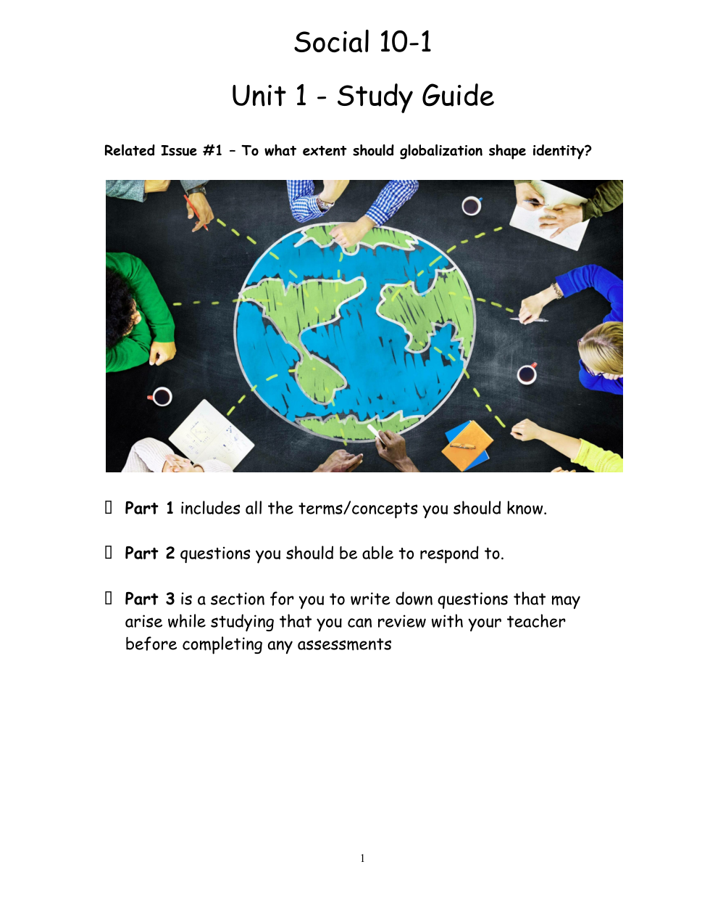
Rendered PDF page 2 of 3
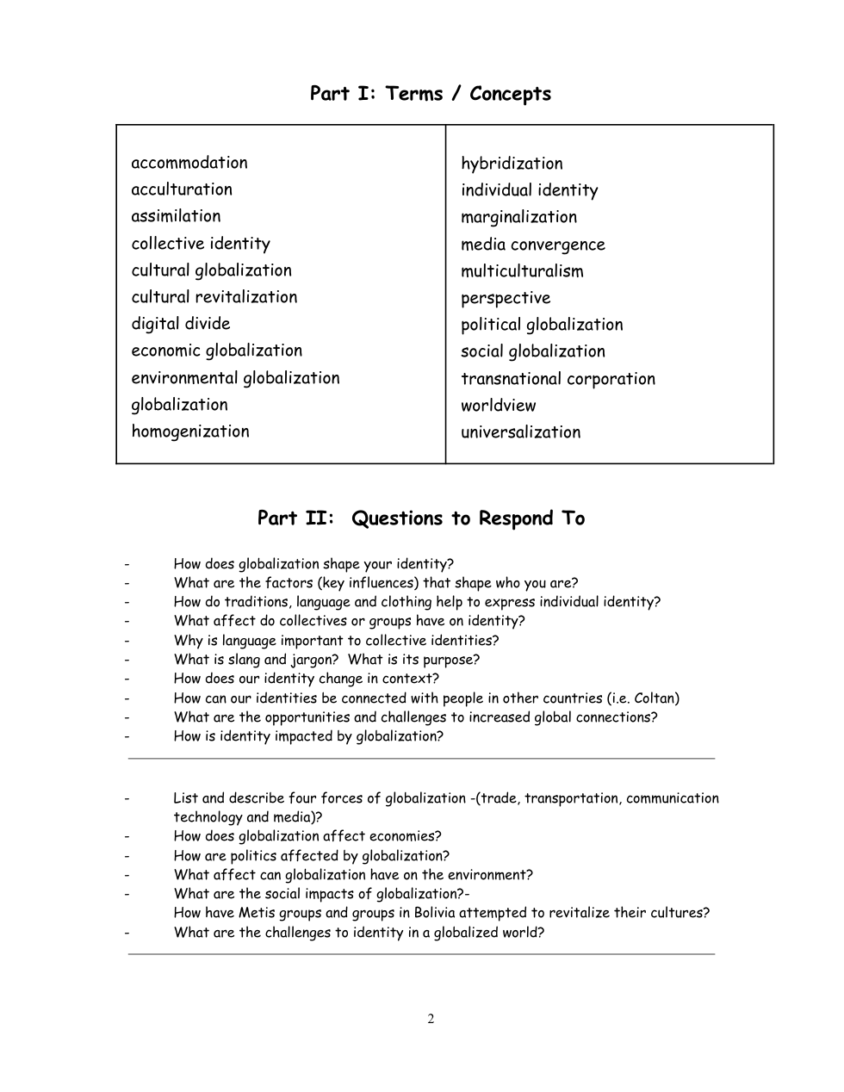
Rendered PDF page 3 of 3
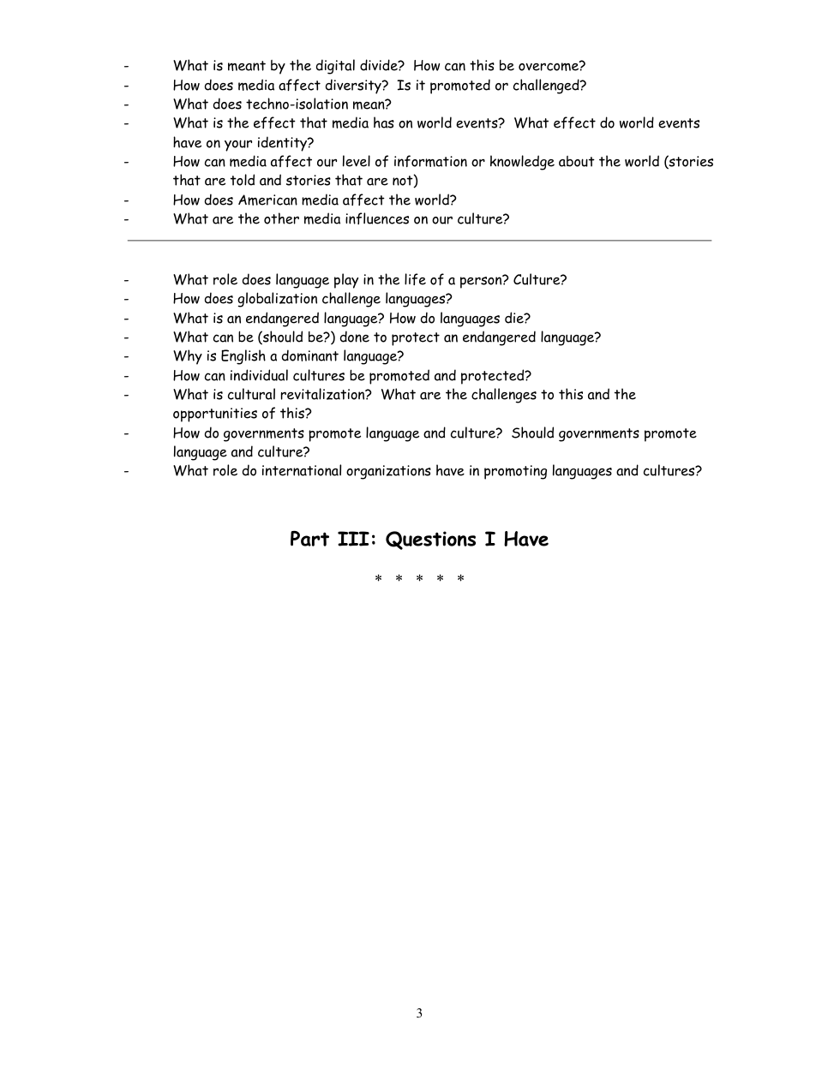



The Source Analysis
In this type of writing you will be presented with three sources. These may be excerpts, graphs, political cartoons, pictures, etc. You will be expected to write an essay in which you analyze each source and identify and explain the relationship(s) that exist among the sources.
Essay Format
The essay should be in the following format:
Introduction:
- Provide the purpose of the paper (1-2 sentences)
Paragraphs 1, 2, 3 (Sources 1, 2, and 3 respectively):
Interpret and explain the source and how it relates to globalization by following the steps below:
- explain/ describe what you literally see in the source, or what the source is saying
***make sure you indicate who would have said this (if applicable)
- link a social studies concept (given to you in the questions) to the source
- define the social studies concept
- give examples as to how the source is an example of that concept
- link the social studies concept to globalization.
Paragraph 4:
Identify and explain the relationship(s) that exists among the sources by referring to the following prompts:
- What is the common social studies concept between all 3 sources?
- Define the social studies concept.
- Source 1 is an example of (the social studies concept) because…
- Source 2 is an example of (the social studies concept) because…
- Source 3 is an example of (the social studies concept) because…
- Compare and contrast each source against the other two sources (you can also do this in steps c, d, e
- Link the social studies concept back to globalization
Possible Sentence Starters
Paragraphs 1, 2, 3 (Sources 1, 2, and 3 respectively):
- In Source One [what do you see or paraphrase if a quotation] …
- The perspective of globalization being presented is… This is demonstrated by [prove it by referring to what you see]
- One can see this [prove it by referring to current events/issues and USE TERMINOLOGY discussed in the unit] …
Paragraph 4 (Identify and explain the relationship(s) that exists among the sources):
- Source One and Source Two are similar [be specific] because… Yet they are different because…
- Common aspects of Source Two and Source Three [be specific] are… Yet they differ because…
- Source One and Source Three demonstrate a connection because… The contrasting element present in Source One and Three is…
Use the sources and graphic organizer available to structure your analysis. (You will gain access to these when you have handed in your unit assignment).
this link opens in a new window/tab)

